Experiment No-02
Study of CMOS NAND Gate Schematics in Cadence Virtuoso Software
1.1 Objectives
The main objectives of this experiment are summarized as:
- To understand the concept and operation of a two-input CMOS NAND gate as a fundamental building block of digital logic circuits.
- To become familiar with the Cadence Virtuoso schematic editor and the standard IC design flow used to create standard cells.
- To design the transistor-level schematic of a two-input CMOS NAND gate, using two parallel PMOS transistors as the pull-up network and two series NMOS transistors as the pull-down network from the gpdk090 technology library, and to generate its schematic symbol.
- To construct a test bench for the NAND gate, with two independent pulse sources at its two inputs, and verify its functionality through transient simulation using Spectre in the Analog Design Environment (ADE L).
- To obtain and analyze the transient input/output wave-forms of the designed NAND gate for all combinations of its two input signals, and to verify them against the NAND truth table.
Keywords- CMOS NAND gate, NMOS, PMOS, Cadence Virtuoso, schematic editor, Spectre, transient response, truth table, standard cell.
1.2 Theory
A NAND gate is a fundamental digital logic gate whose output is the complement of the logical AND of its inputs. For a two-input NAND gate with inputs A and B and output Y, the operation is expressed by the Boolean expression Y = (A·B)′. The output is LOW (logic 0) only when both inputs are HIGH (logic 1); for every other combination of inputs, the output is HIGH (logic 1). The truth table of an ideal two-input NAND gate is shown in Table-1.1.
A | B | Y = (A·B)′
0 | 0 | 1
0 | 1 | 1
1 | 0 | 1
1 | 1 | 0
Table-1.1. Truth table of an ideal two-input NAND gate.
1.2.1 The CMOS NAND Gate
A Complementary Metal-Oxide-Semiconductor (CMOS) NAND gate implements the NAND function using two complementary networks of transistors: a pull-up network of two PMOS transistors connected in parallel between the output node and the supply voltage VDD, and a pull-down network of two NMOS transistors connected in series between the output node and ground, VSS. The two inputs, A and B, are each connected to the gate of one PMOS transistor and one series NMOS transistor, and the drains of the top PMOS device and the top NMOS device are tied together to form the single output terminal.
The output node is pulled down to ground only when both series NMOS transistors are simultaneously ON, which occurs only when both A and B are HIGH; for every other input combination, at least one of the two parallel PMOS transistors is ON, pulling the output up to VDD. Because the pull-up and pull-down networks are never both fully ON at the same time for any static input combination, there is no direct conduction path from VDD to ground, and the static power dissipation of the CMOS NAND gate is ideally zero; power is dissipated mainly during switching (dynamic power) and due to leakage currents in real devices.
1.2.2 Transistor Sizing and the Effect of NMOS Stacking
Unlike a single-input inverter, the pull-down network of a two-input NAND gate consists of two NMOS transistors connected in series (a transistor “stack”). Because the two series devices carry the same current, the effective ON-resistance of the pull-down network is higher than that of a single NMOS transistor of the same width, which tends to slow the falling (HIGH-to-LOW) transition of the output relative to the rising transition.
Because the mobility of holes in a PMOS transistor is lower than the mobility of electrons in an NMOS transistor, a PMOS device must be made wider than an NMOS device of the same length to provide comparable drive strength. In this experiment, the same transistor dimensions used for the earlier CMOS inverter design were retained for the NAND gate: each PMOS device was sized with a total width of 720 nm, and each NMOS device with a total width of 240 nm, for the same channel length of 100 nm, giving the same 3:1 PMOS-to-NMOS width ratio as before. Keeping these dimensions unchanged preserves consistency with the earlier experiment, although the series NMOS stack means the pull-down network is comparatively weaker here than it was for the single-transistor inverter.
1.2.3 Cadence Virtuoso Design Flow
In this experiment, the CMOS NAND gate is designed and verified using the Cadence Virtuoso IC design environment. The overall flow consists of creating a design library attached to a process technology library (gpdk090), drawing the transistor-level schematic in the Schematic XL editor by placing and sizing two PMOS and two NMOS instances and wiring them into the parallel pull-up / series pull-down NAND topology, generating a schematic symbol for the NAND cell, and finally building a separate test bench schematic in which the NAND symbol is instantiated along with two independent input sources and supply sources. The test bench is then simulated using the Spectre simulator inside the Analog Design Environment (ADE L) to verify the NAND gate’s transient behaviour.
1.3 Hardware/Software Used for the Experiment
1. Cadence Virtuoso Schematic Editor (Schematic XL)
2. Virtuoso Analog Design Environment (ADE L)
3. Spectre circuit simulator
4. gpdk090 generic process design kit (technology library)
5. Two NMOS and two PMOS transistors (gpdk090_nmos1v, gpdk090_pmos1v)
6. Two pulse voltage sources (vpulse), a DC voltage source (vdc) and ground (gnd) from analogLib
7. Linux workstation running the Cadence design environment

1.4 Experimental and Simulation Analysis
A design library (NAND_Gate) was created and attached to the gpdk090 technology library, and a schematic cellview (carried over from the earlier inverter template and therefore still internally named inverter) was modified within it to implement the two-input NAND function. Two NMOS and two PMOS instances were placed in the schematic, sized as described in Section 1.2.2, and wired into the parallel PMOS pull-up network and series NMOS pull-down network, with two input pins (A and B), an output pin, and the VDD/VSS supply pins. A schematic symbol was then generated for the NAND cell. A separate test schematic (inverter_test) was built in which the NAND symbol was instantiated with two independent pulse sources at its two inputs and a DC supply and ground connected to its power pins, and the design was simulated in ADE L using the Spectre simulator. Each of these steps is illustrated below.
1.4.1 Transistor Sizing and Parameter Selection
The width and length of each transistor were set in the Add Instance window at the time of placement. As in the earlier inverter design, each NMOS transistor (NM0, NM1) was sized with a total width of 240 nm and a channel length of 100 nm, while each PMOS transistor (PM0, PM1) was sized with a total width of 720 nm and the same channel length of 100 nm, giving the 3:1 PMOS-to-NMOS width ratio discussed in Section 1.2.2. The parameter selection window used for setting the NMOS device dimensions is shown in Figure-1.1.
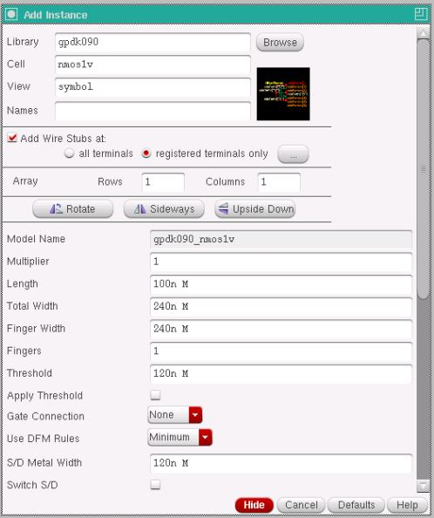
Figure-1.1. Add Instance window showing the width and length parameters set for the NMOS transistor (Total Width = 240n, Length = 100n).
Device | Width (W) | Length (L)
NMOS – NM0, NM1 (gpdk090_nmos1v) | 240 nm | 100 nm
PMOS – PM0, PM1 (gpdk090_pmos1v) | 720 nm | 100 nm
Table-1.2. Device parameters used for the NMOS and PMOS transistors in the NAND gate schematic.
1.4.2 Transistor-Level Schematic of the CMOS NAND Gate
The two PMOS transistor sources were connected to the VDD pin and connected in parallel between VDD and the output node, while the two NMOS transistors were connected in series between the output node and the VSS pin, with the drains of the top PMOS and top NMOS devices tied together to form the output net (Vout). The gates of one PMOS and one series NMOS were tied together to form input A (Vin1), and the gates of the other PMOS and NMOS were tied together to form input B (Vin2). The complete transistor-level schematic of the CMOS NAND gate, with all pins and wires labelled, is shown in Figure-1.2.
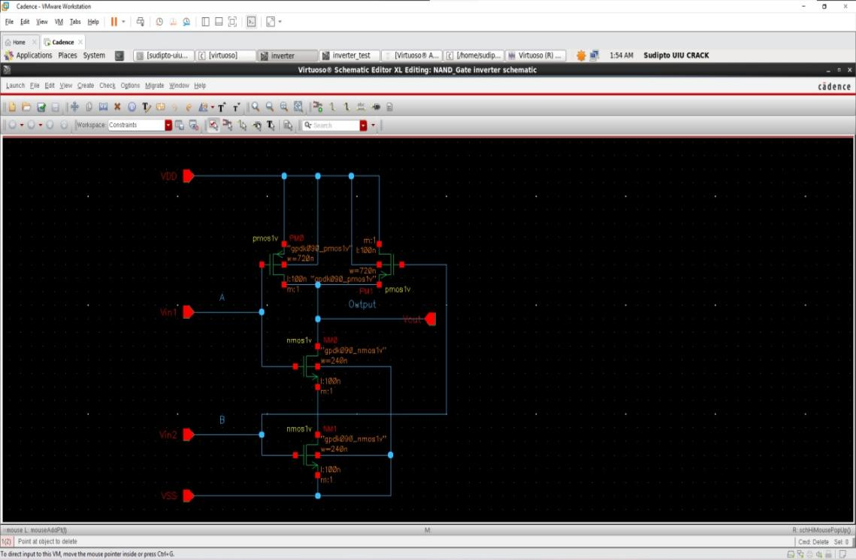
Figure-1.2. Complete transistor-level schematic of the CMOS NAND gate, showing the two parallel PMOS transistors (PM0, PM1) forming the pull-up network, the two series NMOS transistors (NM0, NM1) forming the pull-down network, and the A, B, Vout, VDD and VSS pins.
1.4.3 Schematic Symbol Generation
After the schematic was checked and saved without errors, a schematic symbol was generated from the cellview using Create → Cellview → From Cellview, with Vin1 (A) and Vin2 (B) placed as the two left-side input pins, Vout placed as the right-side output pin, and VDD and VSS placed as the top and bottom pins. The default shape generated by Virtuoso was replaced with the conventional two-input NAND symbol, a curved AND-gate body with an output bubble, as shown in Figure-1.3.
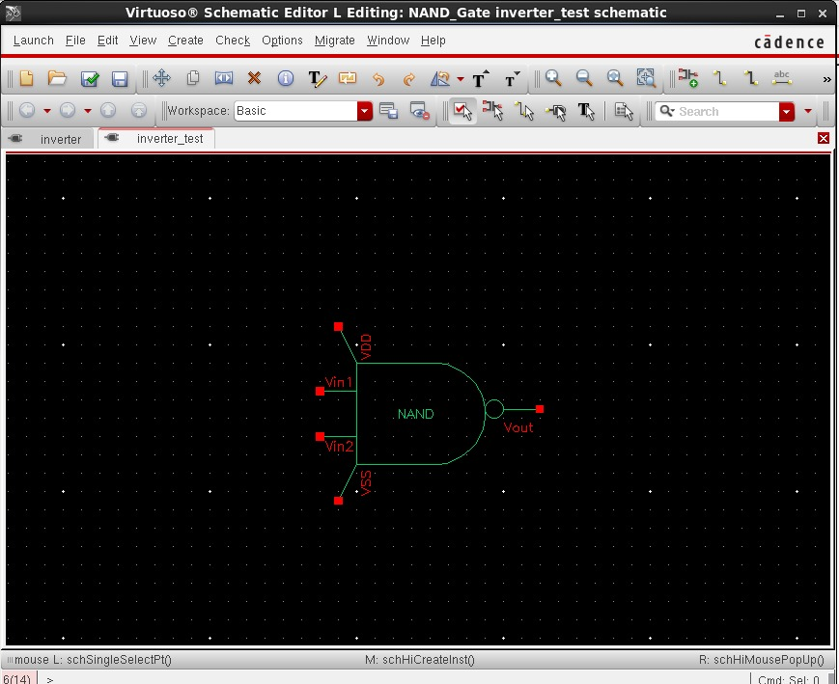
Figure-1.3. Generated schematic symbol of the CMOS NAND gate, showing the two inputs Vin1 and Vin2, the output Vout, and the VDD and VSS supply pins.
1.4.4 Test Bench Construction and Source Addition
A separate schematic, inverter_test, was created to verify the NAND gate. The generated NAND symbol was instantiated, and two independent pulse voltage sources (vpulse) from analogLib were connected to its two inputs: source V1 was connected to input A (Vin1) with voltage1 = 0 V, voltage2 = 1.8 V, period = 20 ns and pulse width = 10 ns, while source V2 was connected to input B (Vin2) with voltage1 = 0 V, voltage2 = 1.8 V, period = 40 ns and pulse width = 20 ns, so that all four input combinations of A and B are exercised over the course of the simulation. A DC voltage source (vdc) set to 1.8 V and a ground (gnd) were connected to the VDD and VSS pins respectively, and the input and output nets were named Vin1, Vin2 and Vout using Create → Wire Name. The completed test bench, with all sources added, is shown in Figure-1.4.
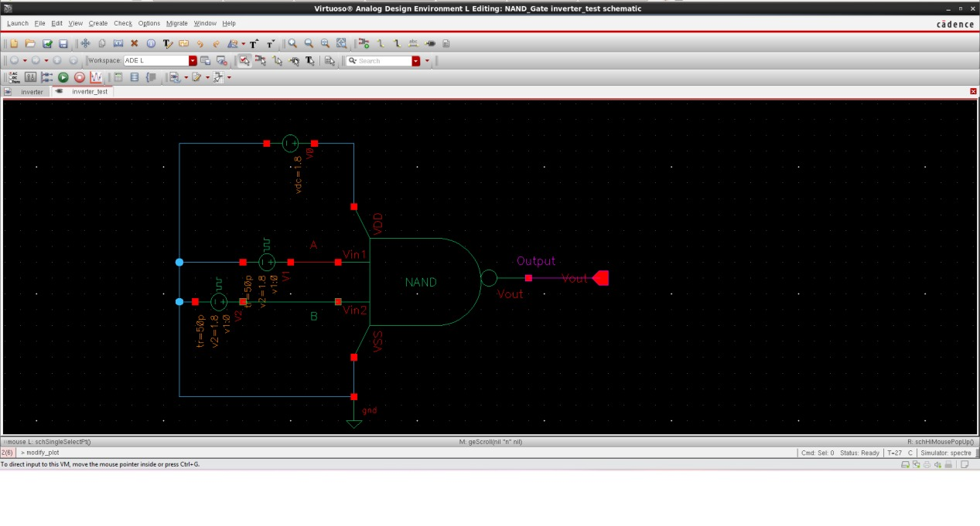
Figure-1.4. Test bench schematic (inverter_test) with the two pulse input sources V1 and V2, the DC supply, ground, and the NAND symbol, with the Vin1, Vin2 and Vout nets labelled.
1.4.5 Input Source Parameter Selection
The Add Instance windows used to configure the two pulse sources and the DC supply are shown in Figure-1.5, Figure-1.6 and Figure-1.7. Figure-1.5 shows the parameters of source V1 driving input A, with Voltage 1 = 0 V, Voltage 2 = 1.8 V, a period of 20 ns, a pulse width of 10 ns, and rise/fall times of 50 ps. Figure-1.6 shows the parameters of source V2 driving input B, configured identically except for a longer period of 40 ns and a pulse width of 20 ns, so that B toggles at half the frequency of A. Figure-1.7 shows the Add Instance window for the vdc source used to set the VDD supply to a DC voltage of 1.8 V.

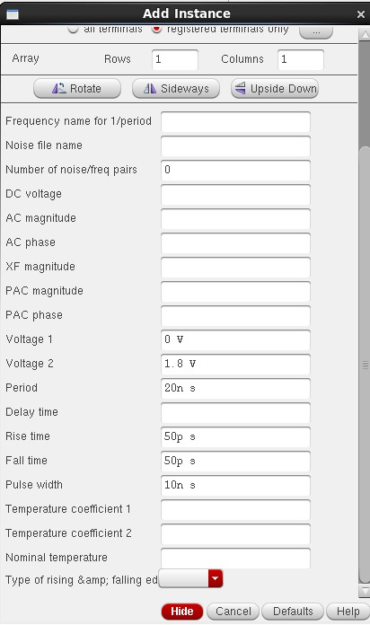 | 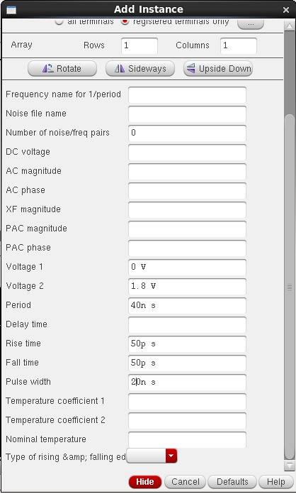
Figure-1.5. Add Instance window showing the pulse source V1 (NAND input A): Voltage 1 = 0 V, Voltage 2 = 1.8 V, period = 20 ns, pulse width = 10 ns. | Figure-1.6. Add Instance window showing the pulse source V2 (NAND input B): Voltage 1 = 0 V, Voltage 2 = 1.8 V, period = 40 ns, pulse width = 20 ns.

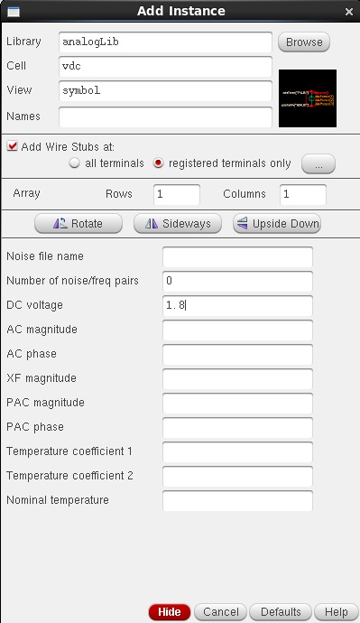
Figure-1.7. Add Instance window showing the vdc source used for the VDD supply, set to a DC voltage of 1.8 V.
1.4.6 Simulation Setup
The test bench was simulated in ADE L using the Spectre simulator, with the gpdk090 Spectre model library added under Setup → Model Libraries. A transient analysis was configured with a stop time of 200 ns so that several cycles of both the 20 ns-period input A and the 40 ns-period input B were captured. The input nets A and B and the output net Vout were selected as the outputs to be plotted, and the simulation was run using Simulation → Netlist and Run.
1.4.7 Simulation Results: Input and Output Wave-forms
Figure-1.8 shows the simulated transient response of the NAND gate. In this response, A is a periodic pulse waveform switching between 0 V and 1.8 V with a 20 ns period and a 10 ns pulse width, and B is a periodic pulse waveform switching between 0 V and 1.8 V with a 40 ns period and a 20 ns pulse width, so that the two inputs together step through all four logic combinations — (0,0), (0,1), (1,0) and (1,1) — over the course of the simulation. The output Vout is observed to remain HIGH for every input combination except when A and B are simultaneously HIGH, during which Vout switches LOW, in direct agreement with the two-input NAND truth table given in Table-1.1.
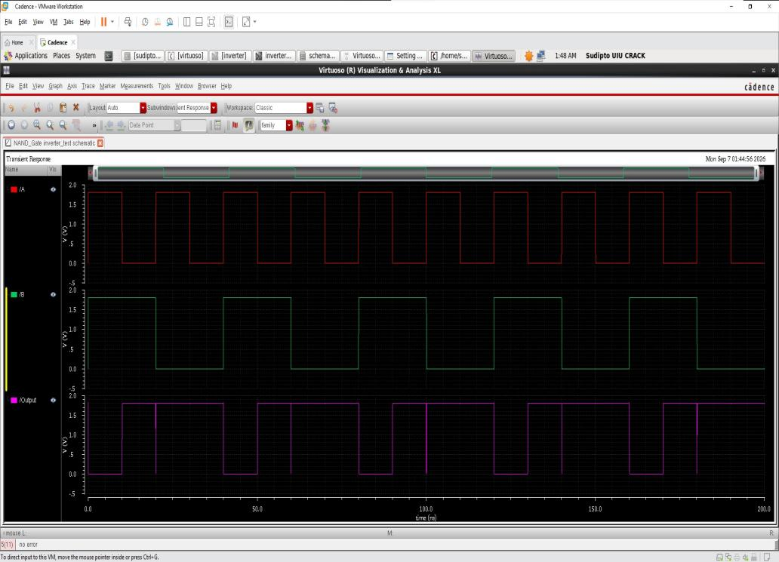
Figure-1.8. Simulation results: transient response showing the two pulse inputs A and B and the resulting NAND output Vout.
1.5 Discussion
The simulated behaviour of the designed circuit was found to be in agreement with the theoretical operation of a CMOS NAND gate described in Section 1.2. The transient simulation confirmed that the output was pulled LOW only during the intervals when input A and input B were simultaneously HIGH, and remained HIGH for the other three input combinations, matching the expected truth table (Table-1.1) in every cycle. Because the series NMOS pull-down network and the parallel PMOS pull-up network are never both fully ON for the same static input combination, the circuit is also expected to dissipate negligible static power, consistent with the fundamental advantage of CMOS logic. Retaining the same transistor dimensions used for the earlier CMOS inverter (WP = 720 nm, WN = 240 nm, L = 100 nm for all devices) kept the design consistent with that experiment, although the NMOS stack in the pull-down path is expected to make the HIGH-to-LOW transition somewhat slower than in the single-transistor inverter case; this trade-off did not affect the correctness of the logical output observed in simulation.
1.6 Conclusion
In this experiment, a two-input CMOS NAND gate was successfully designed at the transistor level in Cadence Virtuoso, using two parallel PMOS transistors as the pull-up network and two series NMOS transistors as the pull-down network from the gpdk090 technology library, and its schematic symbol was generated. A test bench was constructed with two independent pulse sources at the two inputs and a DC supply, and the circuit was verified through transient simulation using Spectre in ADE L. The observed input-output wave-forms confirmed that the circuit correctly performs the logical NAND operation, producing a LOW output only when both inputs were simultaneously HIGH, consistent with the NAND truth table. This experiment provided practical, hands-on experience with extending a basic standard-cell schematic design flow from a single-input inverter to a multi-input logic gate, which forms the basis for more complex digital and mixed-signal IC design in subsequent experiments.

